|  |  |  |
| --- | --- | --- |
|  | **Reporting With SAP Crystal Reports** | |
| MOTIVATION  This material is an introduction to how to develop report utilizing SAP Crystal Reports. It is aimed at students at universities, universities and other educational institutions with limited experience with Business Intelligence.  It can be used in the classroom or for self-study.  On completion of the course, students will be able to understand the basic concepts of reporting and develop reports with this tool.  The material also serves as a reference for occasional users of SAP systems. | LEARNING METHOD  The learning method used is “guided learning.” The benefit of this method is that knowledge is imparted quickly. Students also acquire practical skills and competencies. As with an exercise, this method explains a process or procedure in detail.  Exercises at the end enable students to put their knowledge into practice. |
| Product  SAP Crystal Reports  Level  Beginner  Focus  Report Development  Author  Paul Hawking  Version  1 |  |  |

SAP Business Intelligence provides a broad range of reporting tools to facilitate decision making of the different end users. SAP Crystal Reports is reporting tool that is used to formatted reports. SAP Crystal Reports makes it easy to create simple reports, and, it also has the comprehensive tools you need to produce complex or specialized reports. Built-in report experts guide you step by step through building reports and completing common reporting tasks.

## Reporting Scenario

[](http://puma.scb.gvsu.edu/irj/go/km/docs/wpccontent/Sites/ERP%20Initiative%20Content/Site%20Content/Articles%20&%20Press/Images/GBI%20logo.jpg)Global Bike International (GBI) is a world class bicycle company serving both professional and amateur cyclists. The company sells bicycles and accessories. In the touring bike category, GBI’s handcrafted bicycles have won numerous design awards and are sold in over 10 countries. GBI’s signature composite frames are world-renowned for their strength, low weight and easy maintenance. GBI bikes are consistently ridden in the Tour de France and other major international road races. GBI produces two models of their signature road bikes, a deluxe and professional model. The key difference between the two models is the type of wheels used, aluminium for the basic model and carbon composite for the professional model. GBI’s off-road bikes are also recognized as incredibly tough and easy to maintain. GBI off-road bikes are the preferred choice of world champion off road racers and have become synonymous with performance and strength in one of the most gruelling sports in the world. GBI produces two types of off-road bike, a men’s and women’s model. The basic difference between the two models is the smaller size and ergonomic shaping of the women’s frame.

GBI also sells an Accessories product line comprised of helmets, t-shirts and other riding accessories. GBI partners with only the highest quality suppliers of accessories which will help enhance riders’ performance and comfort while riding GBI bikes. Figure 1 displays the GBI range of products.

Traditionally GBI was a wholesaler who sold their bikes to retailers who then resold the bikes to the end consumers. Recently GBI has decided to sell their bike to the end consumer via the internet.

Organisational Structure

GBI’s headquarters are located in Dallas and the European subsidiary company (GBI Europe) is based in Heidelberg, Germany. In regards to the GBI sales process there are two sales organisations for America (Eastern US and Western US) and two for Germany (Northern Germany and Southern Germany). All sales organisations have a wholesale distribution channel responsible for delivering the products to the customers. However only one sales organisation is required in each country to support internet sales. The diagram below displays the GBI organisation to support the sales process.

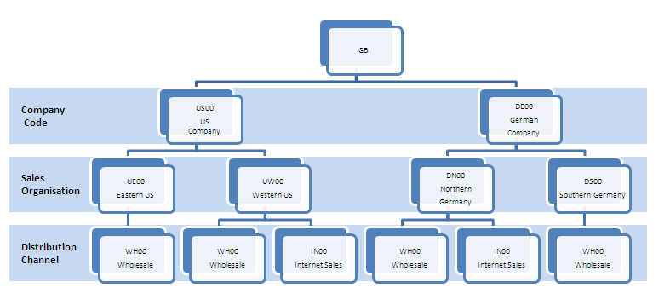

**Requirements**

GBI management currently SAP ECC to manage and automate their business processes.. The Department Heads have indicated that require a simple report which displays the Price List for the products which GBI sell. It was decided to build a report using SAP Crystal Reports.

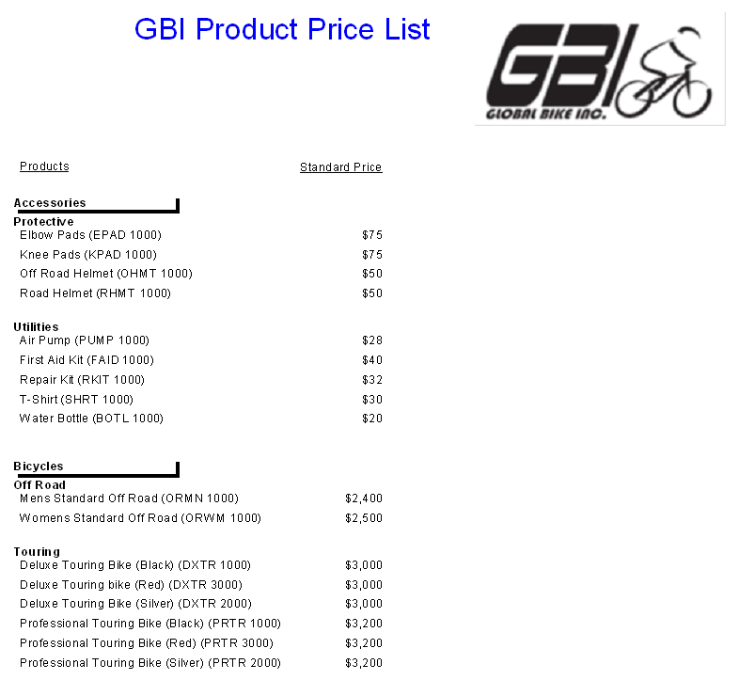

## Opening Crystal reports

1. Choose **Start** ⇨ **All** **Programs** ⇨ **SAP Business Intelligence** ⇨ **SAP** **Crystal Reports 2013** ⇨ **Crystal Reports 2013**. [As of the start of spring 2015, we have now migrated to using **Crystal Reports 2013**].

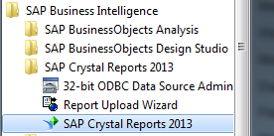

If you cannot find the application in your PCs menu, type *crystal* in the Windows search bar.

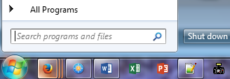

**Crystal Reports** appears on screen (the menu is the same for both CR 2011 & CR 2013).



SAP Crystal Reports provides users with a number of alternatives for report creation including wizards (Standard, Cross-Tab, Mailing Label, and OLAP). These wizards guide the user through a number of input screens to create a report.

**Standard Report Wizard** guides the user through choosing a data source and linking database tables. It also helps the user add fields and specify the grouping, summarization (totals), and sorting criteria to be used. The wizard also assists in the creation of a chart and record selection.

**Cross-Tab Wizard** guides users through the creation of a report in which the data is displayed as a cross-tab object.

**Mailing Labels Wizard** guides the user to create a report that is formatted to print on any size mailing label. The Label screen is used to select a commercial label type, or a user can define their own layout of rows and columns for any multi-column style report.

**OLAP Wizard** guides the user to create a report in which OLAP data is displayed as a grid object which includes dimensions from the OLAP data source.

For the purpose of this tutorial you will create a report without the use of a wizard.

2. Click  to create a new report..

The **Database Expert** dialog screen appears.

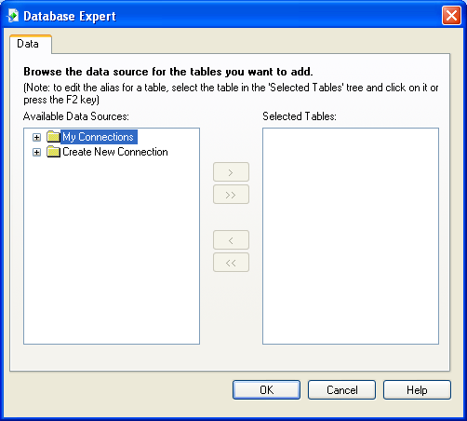

## Selecting a data source

You can create reports based on a variety of data sources. However before you can create a report you need to create a connection to the required data source. You are going to connect to the GBI data source which is in a Microsoft Access format.

3. Click  next to  to expand this folder.

A list of available data sources are displayed. You need to navigate to your data source (C:\GBI.mdb) to create a connection.

4. Click  next to  to display the **Open** dialog screen.

5. Navigate to **C:\****GBI.mdb**. [Note: In CIT 3210, this location may not be available to you due to security reasons. Therefore, you may have to choose another location, such as the Desktop]

To complete this step, one must first download the GBI.mdb file (i.e., Access database) from the Crystal Reports folio assignment website to your C: drive.

6. Click **GBI.mdb** to select the data source.

7. Click  to create a connection between Crystal Reports and the data source.

The tables which are part of GBI.mdb data source are displayed. You now need to select the tables which are to be included in the report.

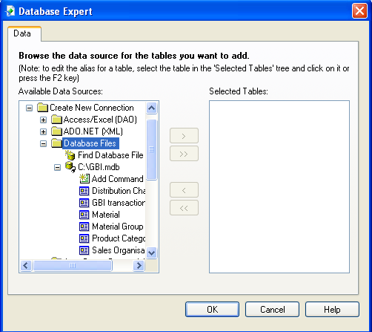

8. Click  to select this table from the data source.

9. Click  to transfer this table.

10. Repeat the process for the remaining tables in your data source.

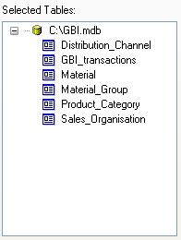

11. Press **<ENTER>** to continue.

The Database Expert displays the tables form the data source. It displays the primary keys  of each table and the links between tables.

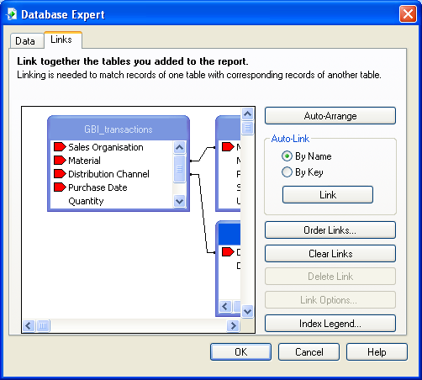

12. Drag the **Database Expert** screen to re-size it so all tables appear.

You will notice that the **Database Expert** has predicted most of the links between tables. However due to the same field having different names (*SalesOrg* and *Sales Organistion*) in different tables the Database Expert was not able to predict this link. You will have to create this link manually.

13. Click *SalesOrg* to select this field in the *Sales_Organisation* table.

14. Drag the selected field to *Sales Organisation* in the *GBI_Transactions* table to create a link.

The link appears between the two fields.

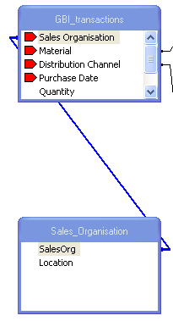

Note if you make a mistake to can delete a link by selecting it and pressing **<DELETE>.**

15. Click  to continue.

A blank report appears on screen in **Design** mode .

16. Click  to maximise Crystal Reports.

## Screen Components

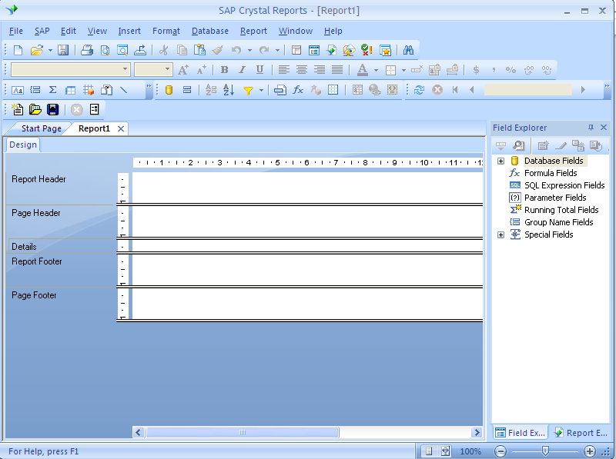

The Crystal Reports Design tab is divided into five sections:

**Report Header** (RH)- This section is generally used for the report title and other information you want to appear at the beginning of the report. It can also be used for charts and cross-tabs that include data for the entire report.

**Page Header** (PH)- This section is generally used for information that you want to appear at the top of each page. This can include such things as chapter names, the name of the document, and other similar information. This section can also be used to display field titles above the fields on a report.

**Details** (D)- This section is used for the body of the report, and is printed once per record. The bulk of the report data generally appears in this section.

**Report Footer** (RF) - This section is used for information you want to appear only once at the end of the report (such as grand totals) and for charts and cross-tabs that include data for the entire report.

**Page Footer** (PF) - This section usually contains the page number and any other information you want to appear on the bottom of each page.

Another area of the Crystal Reports **Design** tab is the **Field Explorer**. The **Field Explorer**, as the name implies, contains the fields that can be included in a report.

17. Click  next to  to display the tables from your data source.

18. Click  next to  to display the fields in this table.

19. Repeat this process for each table in your data source.

## Inserting fields into a report

You include a field in your report by dragging the field to the section of the report where it is to appear. Sometimes it is difficult to remember the particular field you require especially when there are many fields. Crystal Reports provides the opportunity to browse the data for a field in the **Field Explorer**.

20. Right Click *Material* in the *Material* table to display the context menu.

21. Click **Browse Data...**

A dialog box appears with the data from this field.

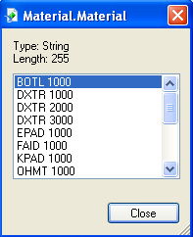

22. Click  to close the dialog box.

23. Drag  into the far left of the **Details** section to include this field in the report.

Notice as you drag the field an object frame appears to indicate the field’s location.



The *Material* field appears in the report. Also notice that a tick appears adjacent to this field in the **Field Explorer**. 

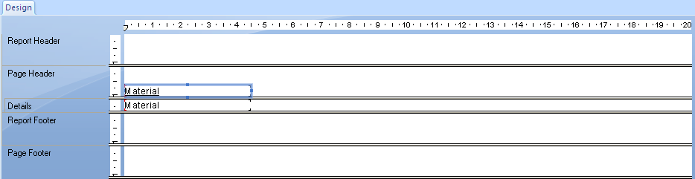

Notice that *Material* appears in the **Page Header** and **Details** sections. The *Material* in the **Page Header** section is the heading of the column which contains the values for the *Materials* in the **Details** section. As you would have noticed previously that the Material field includes the codes for each Material. To make the report more meaningful you are now going to include The *Material Description* for each *Material*.

24. Drag  into the **Details** section adjacent to *Material* to include this field in the report.

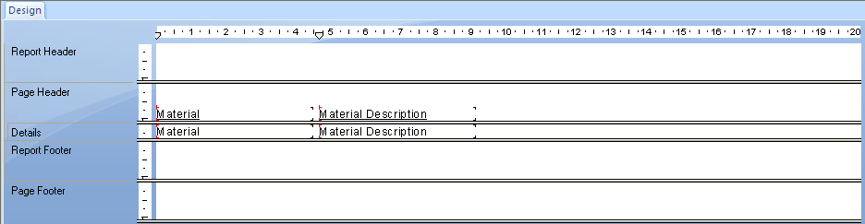

## Previewing your report

You can preview your report at any time to verify that it contains the data you require and it is formatted appropriately. The first time you preview a report you click the **Print Preview** icon  on the **Standard toolbar**. This displays the report and activates the **Preview** tab to the right of the **Design** tab. This enables you to be able to quickly switch between the two tabs. You can make changes to the report on the **Design** tab and then view the impact of these changes through the **Preview** tab.

25. Click  on the **Standard toolbar** to preview your report.

Your report appears on screen.

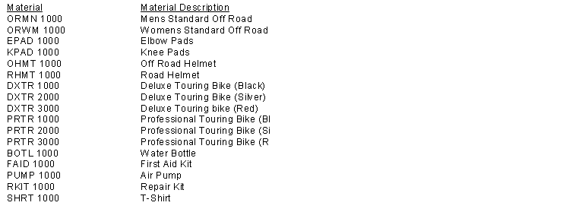

Notice that the **Preview** tab now appears on screen.



If you examine your report closely you will notice that some Material Description values (Professional Touring Bike) have been truncated due to the size of the field in the report.

## Re-sizing fields

Often the fields in your report may not be wide enough to display the data. The data will be either truncated or **XXXXXXX** will be displayed in the field. You can easily re-size fields in the **Design** tab by clicking the required field to display the handles and then drag the handles to increase or reduce the size of the field. This can be applied separately to the field in the Details section or in combination with the **Page Header** field. You can use the **<CTRL>** **click** technique to select more than one field to re-size.

26. Click  to display the **Design** view.

27. Click *Material Description* in the **Details** section to select it.



28. Drag the right handle to increase the field size by approximately 2 cm.



29. Click  to view the changes to your report.

Notice that the *Material Description* field has been re-sized and the first row and the field have been selected.

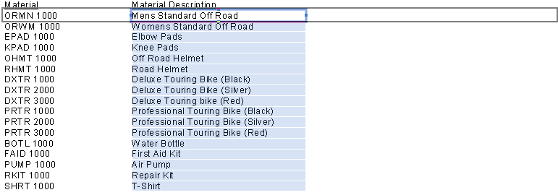

30. Click a white area of your report to de-select the field and record.

You should now save your report before continuing.

31. Click  to display the **Save** dialog screen.

32. Type **GBI Report1 <your name>** in the File name: text field.

33. Navigate to the **My Documents** folder.

34. Click  to complete the process.

Notice that the file name appears on the report tab and the **Title bar.**

## Changing the order of fields

You have included two fields (*Material and Material Description*) in your report. You can use the drag and drop functionality to include additional fields in your report. Ass you design the report you may find that fields are not in the correct placement. You can easily change location of a field through drag and drop functionality. Management would prefer to display the *Material Description* field first.

35. Click  to display the **Design** view.

36. Click *Material* in the **Page Header** section to select it.

37 Press **<CTRL>** and **click** *Material* in the **Details** section to also select it.

38. Drag both fields to the right of *Material Description*.

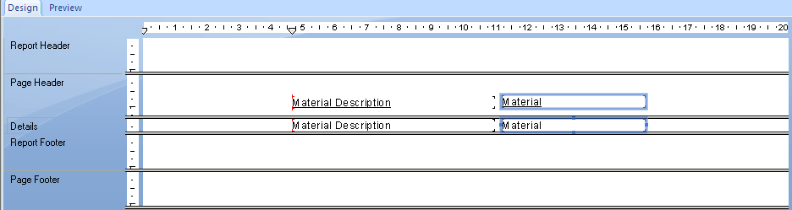

You can also select multiple fields by dragging the mouse around the fields to be selected.

39. Drag the mouse around the fields to select all of them.

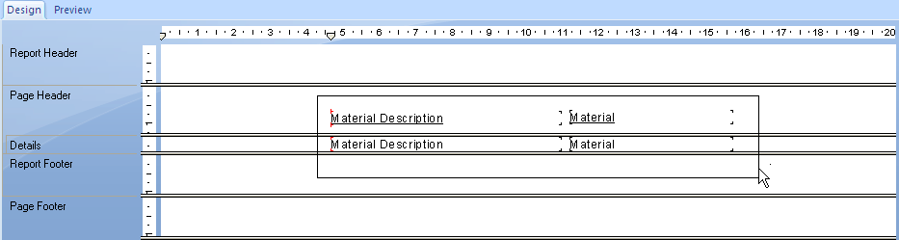

40. Press left arrow key (🡸) on the keyboard until the fields have been moved to the left of the report.

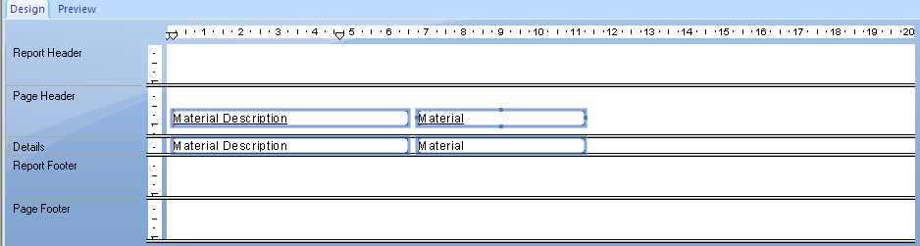

41. Click  to save the report.

42. Click  to view the changes to your report.

## Combining fields

Management have indicated that rather than having a separate field for the *Material* code that they would like this data to be displayed with the *Material Description*. Crystal Reports provides the functionality to combine more than one field and or text in a **Text object**. This can improve the appearance of the report as any unnecessary white space in a field is removed.

43. Click  to display the **Design** view.

44. Click  **Insert Tex Object** on the **Insert toolbar**.

Notice the cursor changes to .

45. Drag to create a **Text object** in the **Details** section to the right of *Material*.

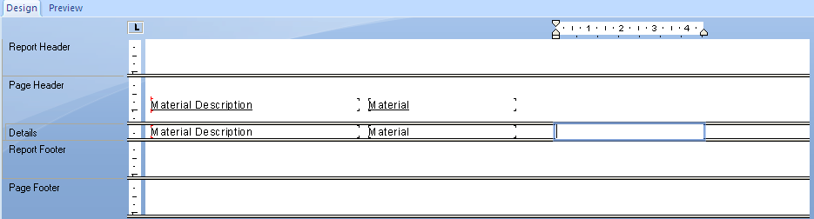

*If the* ***Text object*** *appears in the wrong location – select and delete it, then repeat the process.*

You now need to define the contents of the **Text object**.

46. Double click the inside the **Text object** to select it for editing.

47. Drag  from the **Field Explorer** into the **Text object**.

When you release your mouse the field appears in the **Text object**.



The require format for the field is *Material Description* (*Material*).

48. Press **<SPACE>** to insert a space.

49. Type **(**

50. Drag  into the **Text object** after **(**.

51. Type **)**

The **Text object** appears as follows.



52. Click  to save the report.

53. Click  to view the changes to your report.

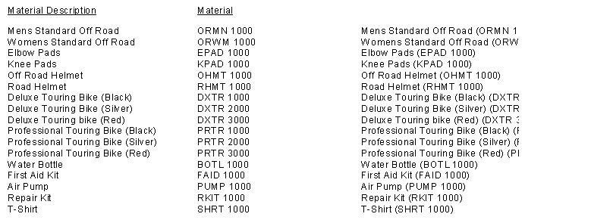

Notice that the *Material Description* and *Material* are now combined in the one field.

54. Re-size the **Text object** if required to include all data.

55. Click  to display the **Design** view if not already on this screen.

56. Insert a **Text object** in the **Page Header** section above the existing **Text object**.

57. Type **Products** in the **Text object**.

58. Click  to view the changes to your report.

59. Click  to save the report.

## Removing fields

As you have combined the *Material Description* and *Material* fields in the **Text object** there is no point duplicating these on the report. You can also easily remove fields from your report by selecting the field and the pressing **<DELETE>**.

60. Click  to display the **Design** view.

61. Delete *Material Description* and *Material* fields from the **Details** section

Notice that the corresponding fields in the **Page Header** are also removed.

62. Move remaining fields to the left of the report.

63. Click  to view the changes to your report.

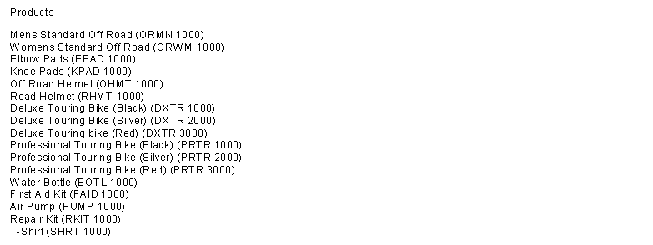

64. Click  to save the report.

## Sorting the data

To make the report easier to navigate the data should be sorted. The  on the **Experts toolbar** displays the **Record Sort Expert** to assist with the sorting process. You have decided to sort the *Material Description* alphabetically.

65. Click  to display the **Design** view.

66. Click  on the **Experts toolbar**.

The **Record Sort Expert** appears on screen.

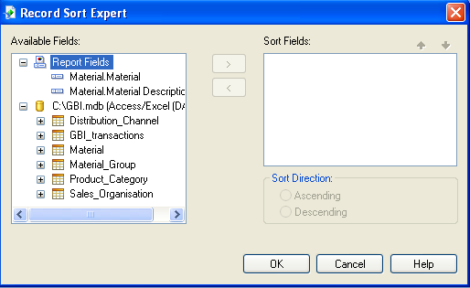

Notice that all the tables and fields from the data source are listed as well as the fields contained within the report.

67. Click  to select this field.

68. Click  to move the selected field to the sort criteria.

69. Click  to apply the sort criteria to your report.

70. Click  to view the changes to your report.

The products are now sorted by *Material Description*.

71. Click  to save the report.

## Grouping data

The *Materials* in GBI are categorised by *Material Group* (Accessories and Bicycles) and then by *Product Category* (Accessories – Protective/Utilities; Bicycles – Off Road/Touring). The report would be more meaningful if the *Materials* were **grouped** by *Material Group* and *Product Category*.

You can insert a grouping your report by using the **Group Expert** icon on the **Expert toolbar**. You can add a **grouping** either in **Design** or **Preview** mode.

72. Click  on **Expert toolbar** to display the **Group Expert** dialog screen.

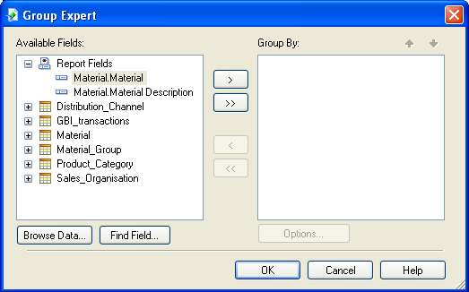

Notice that all the tables and fields from the data source are listed as well as the fields contained within the report.

73. Click  next to  to display the fields of this table.

74. Click “Material Group Description” to select the field.

75. Click  to move the selected field to the **Group By:** criteria.

76. Repeat the process for *Product Category Description* from the *Product_Category* table.

Your screen appears as follows:

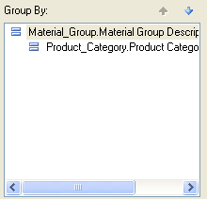

77. Click  to apply the **grouping** criteria to your report.

The products are now grouped by *Material Group* and *Product Category*

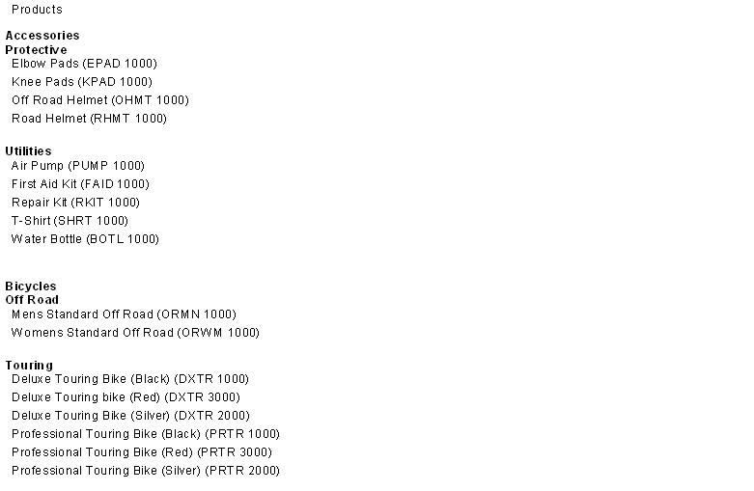

78. Click  to save the report.

The grouping of fields creates new sections (Group Header and Group Footer) for each grouping in your report.

79. Click  to display the **Design** tab and view the new sections.

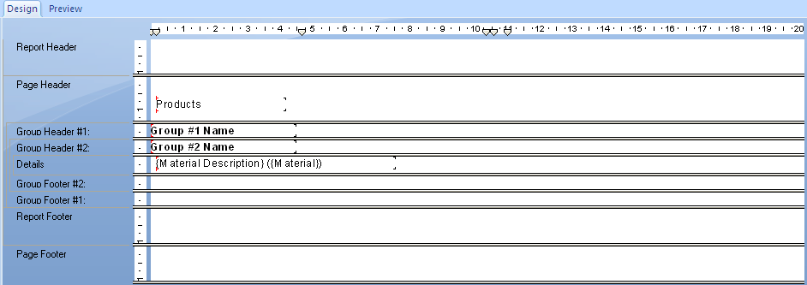

Management have decided that rather than creating a Product List for distribution to the different Sales Organisations that they would also like to include prices for each product. Presently prices are determined in US dollars and then converted into the local currency. Up till this stage you have added and deleted fields in **Design** tab. You can also perform these functions in the **Preview** tab.

70. Click  to view the changes to your report.

Notice to the left of the **Preview** tab that the different sections are identified.



79. Drag  from the *Material* table to the **Detail** section of any Material.

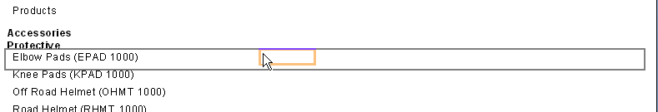

The *Standard Price* for each *Material* is displayed.

## Documenting a report

You should include summary information about your report to provide yourself and future developers with information about why the report was created and who created it.

80. Select the **File** menu then the **Summary Info** command.

The **Document Properties** dialog box appears on screen.

81. Type the following information:

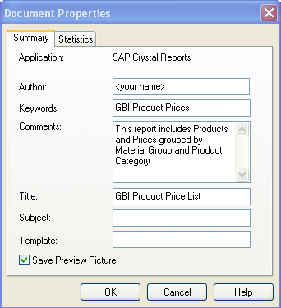

82. Click  to complete the process.

## Formatting a report

Currently your report has limited formatting. The column headings are inconsistent, there is no report title, Standard Price is not formatted as currency and management would like the GBI logo included on the report. Each of these components can be formatted to improve their appearance.

## Adding a title

The Products Price List report needs a Title to describe the contents of the report. You can add a title to your report using a **Text object** or by inserting the information directly from the **Document Properties**. You will use the information from the **Document Properties** through the inclusion of a **Report Title** field from the **Special Fields** in the **Field Explorer**.

83. Click  to display the **Design** view.

84. Click  next to  in the **Field Explore** to display the fields.

85. Drag  to the **Report Header** section of the report.

86. Click  to view the changes to your report.

The report title appears on the report.

You can now format the report title.

87. Right click **GBI Product Price List** to display the context menu.

88. Select **Format Text** to display the **Format Editor** dialog screen.

89. Change the **Font** to size 24 and colour blue.

90. Click  to apply the changes.

## Formatting Fields

91. Format *Products* to include underline.

You will notice that the column headings are not horizontally aligned.

92. Click *Products* heading to select it.

93. Press **<CTRL>** and right click *Standard Price* to display the context menu.

94. Select **Align** then **Bottoms** to align the headings.

When you apply formatting to a field in a section the formatting applies to all fields in that section.

95. Right click Accessories to display the context menu.

96. Select **Format field** to display the **Format Editor** dialog screen.

97. Click **Border**.

98. Click **Drop Shadow** to select this option.

99. Click  to apply the changes.

You now need to format the *Standard Price* to display currency.

100. Right click any of the *Standard Price* values to display the context menu.

101. Select Format Filed.

The **Format Editor** dialog screen appears with various number formats displayed.

102. Click  to select this option.

103. Click  to apply the changes.

## Inserting a graphic

You can insert graphics in your report using the **Insert Picture** icon  on the **Insert toolbar**. You can insert a graphic in either the **Design** or **Preview** tab.

104. Click  on the **Insert toolbar**.

The **Open** dialog box appears.

105. Open **GBI.bmp** (C:\GBI.bmp).

An outline of the graphic appears.

106. Drag the graphic to the right of the **Report Header** section.

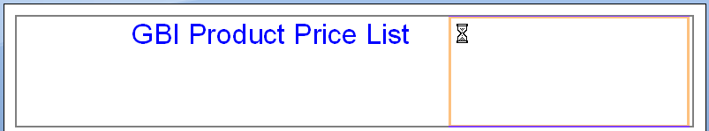

The GBI logo appears after the mouse is released.



107. Click  to save the report.

Your report appears similar to the management’s requirements.



You have now completed the tutorial on Crystal Reports. This tutorial was designed to provide an introduction to this reporting tool and provide the fundamental skills to build reports. There is a relevant submission note for this part on the folio assignment webpage.

**Before submission, please read the additional submission requirements on the assignment web page, such as** **including your last name in the report title.**